**Courier Management Application**

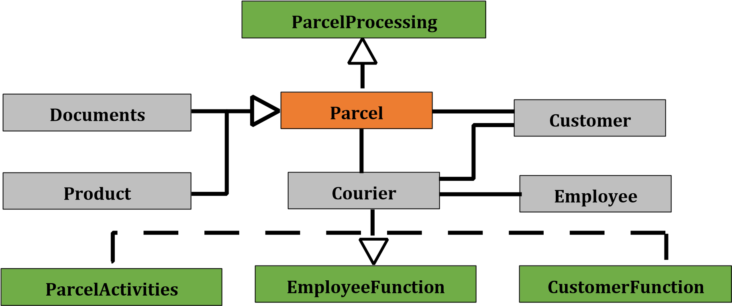

This is an Object Oriented Programing (JAVA) project for a Courier Office.

Customer can Send and Receive parcel from this office. This application helps the employee to done their work preciously. It is an application where they can store Employee Data, Customer Data (Both Sender and Receiver), Customer Location, Parcel type, Charge etc. This information helps the employee to distribute the parcel according to the demand of the customer.

**Group Number : A06 Group Members :**

**A.K.M. Faysol Mahmud Rusho ID: 18-37683-1**

**Md. Asaduzzaman Shadin ID: 18-39011-3**

**Mosaeb Bin Mozib ID: 18-38598-2**

|  |  |  |
| --- | --- | --- |
| **ParcelProcessing** |  | **ParcelActivities** |
| boolean Booking (double Quantity) boolean Receive(double Quantity) | boolean includetparcel(Parcel a) boolean deliver parcelt(Parcel a)  Parcel searchParcel(String ParcelNumber) void showAllParcels( ) |

|  |  |
| --- | --- |
| **CustomerFunction** | **EmployeeFunction** |
| boolean insertCustomer(Customer c) boolean removeCustomer(Customer c) Customer searchCustomer(int nid) void showAllCustomers( ) | boolean insertEmployee(Employee e) boolean removeEmployee(Employee e) Employee searchEmployee(String empId) void showAllEmployees( ) |

|  |  |  |
| --- | --- | --- |
| **Parcel** |  | **Customer** |
| String ParcelNumber Customer customer double balance | int nid  String name  String phnNumber |
| void setParcelNumber(String parcelNumber) void setCustomer(Customer customer) void setBalance(double balance)  String getParcelNumber( ) Customer getCustomer( ) double getBalance( )  abstract void showDetails(  ) | void setNid(int nid) void setName(String name)  void setPhnNumber(String  phnNumber)  int getNid( ) String getName( ) String getPhnNumber( ) void showDetails( ) |
|  |

|  |  |  |  |  |
| --- | --- | --- | --- | --- |
| **Documents** | |  | **Product** |  |
| double Size | | float Weight  void setWeight(float weight) float getWeight( ) |
| void setSize(double size ) double getSize( ) | |
| **Employee** |  | **Courier** | | |
| String empId  String empName double salary | String name  String branchName  Parcel parcels[ ]  Customer customers[ ]  Employee employees[ ] | | |
| void setEmpId(String empId) void setEmpName(String empName)  void setSalary(double salary)  String getEmpId( )  String getEmpName( ) double getSalary( ) void showDetails( ) |
| void setName(String name) void setBranchName(String branchName)  String getName( )  String  getBranchName( ) void showDetails( ) | | |

|  |
| --- |
| **Start** |
| The Start class contains the main method. Inside the main method the application prompts the user to choose among the following options:     1. Employee Management 2. Customer Management 3. Parcel Management 4. Parcel Operation 5. Courier Information 6. Exit     Upon choosing any of the option the user is given some further options to choose from:    **[A. K. M. Faysol Mahmud Rusho]**  *Options for Employee Management:*  *1. Insert New Employee 2. Remove Employee 3. Search Employee 4. Show All Employees 5. Go Back*    *Options for Customer Management:*  *1. Insert New Customer 2. Remove Customer 3. Search Customer 4. Show All Customers 5. Go Back*    **[Md. Asaduzzaman Shadin]**  *Options for Parcel Management:*  *1. Booking New Parcel 2. Cancel Booked Parcel 3. Search Parcel 4. Show All Parcels 5. Go Back*    *Option for Booking Parcel:*  *1.Documents Type Parcel 2. Product Type Parcel 3. Go Back*      **[Mosaeb Bin Mozib]**  *Options for Parcel Operation:*  *1. Deliver Parcel 2. Show Parcel History 3. Go Back* |